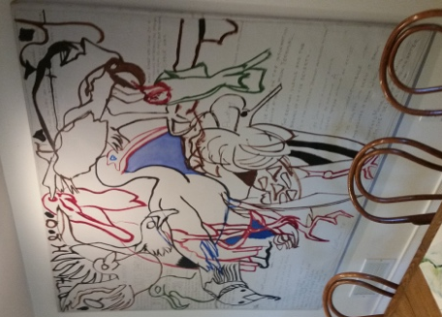 | Musa  Object identifier: EL2018.3.1.1  Artist/Maker: Grace Hartigan (artist)  Object titles: Musa  Date created: 1975  Type: Lightweight Object  Credit line:

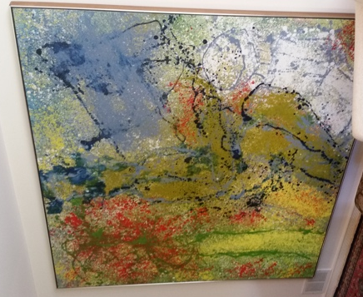 | Central Park  Object identifier: EL2018.3.1.2  Artist/Maker: Grace Hartigan (artist)  Object titles: Central Park  Date created: 1990  Medium and Support: oil on canvas  Type: Lightweight Object  Credit line:

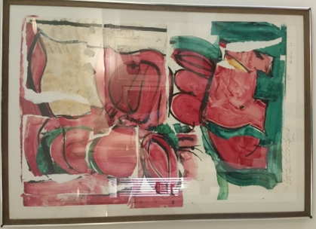 | Untitled  Object identifier: EL2018.3.1.3  Artist/Maker: Grace Hartigan (artist)  Object titles: Untitled  Date created: 1963  Type: Lightweight Object  Credit line:

Paintings, November 1974, Gertrude Kasle Gallery
Object identifier: EL2018.3.1.4
Artist/Maker: Philip Guston (artist)
Object titles: Paintings, November 1974, Gertrude Kasle Gallery
Date created: 1974
Medium and Support: lithograph on paper
Type: Lightweight Object
Credit line:

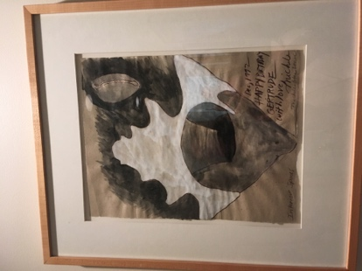 | Interior Spaces  Object identifier: EL2018.3.1.5  Artist/Maker: Michele Oka Doner (artist)  Nationality: American (North American)  Object titles: Interior Spaces  Date created: 1992  Type: Lightweight Object  Credit line:

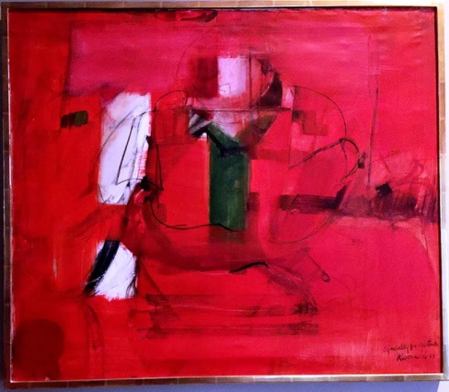 | Especially for Gertrude  Object identifier: EL2018.3.2.1  Artist/Maker: Larry Rivers (artist)  Nationality: American (North American)  Object titles: Especially for Gertrude  Date created: 1956 – 1957  Medium and Support: oil on canvas  Type: Lightweight Object  Credit line:

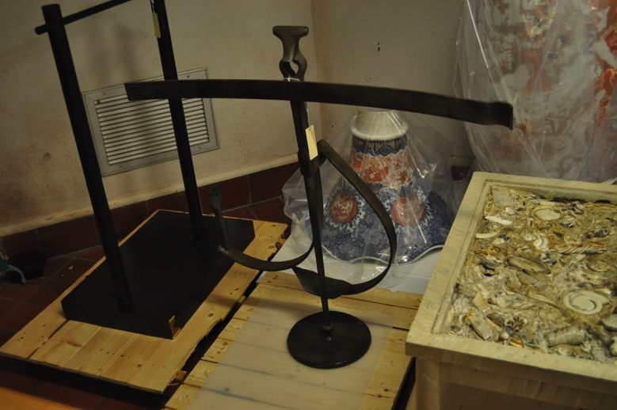 | Untitled  Object identifier: 2016/2.83  Artist/Maker: Morris Brose (artist)  Object titles: Untitled  Date created: 1974 – 1984  Medium and Support: bronze  Type: Object  Credit line: Bequest of Gertrude Kasle, Approved: Yes (current) 07/27/2016

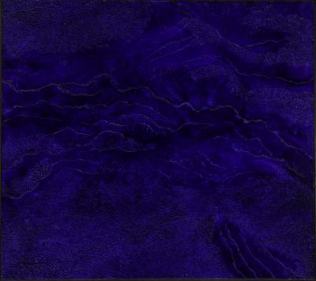 | Journey Without Maps VIII  Object identifier: 2016/2.84  Artist/Maker: David Budd (artist)  Nationality: American (North American)  Object titles: Journey Without Maps VIII  Date created: 1980  Medium and Support: oil on canvas  Type: Object  Credit line: Bequest of Gertrude Kasle, Approved: Yes (current) 07/27/2016

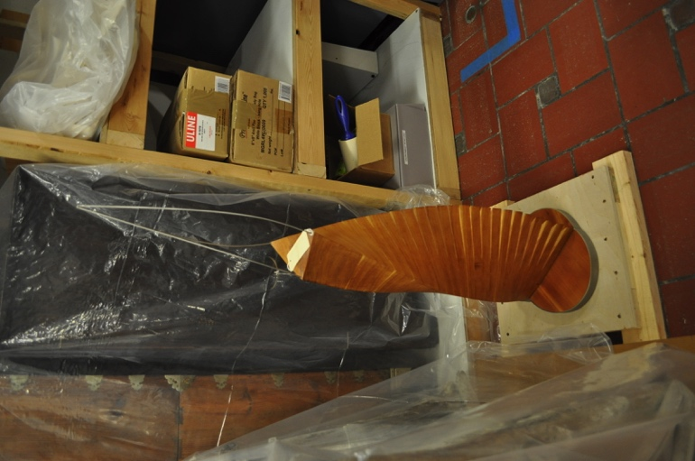 | Divine Triangle  Object identifier: 2016/2.85  Artist/Maker: David E. Davis (artist)  Nationality: American (North American)  Object titles: Divine Triangle  Date created: 2000  Medium and Support: cherry wood and stainless steel  Type: Object  Credit line: Bequest of Gertrude Kasle, Approved: Yes (current) 07/27/2016

Untitled
Object identifier: 2016/2.86
Artist/Maker: Jimmy Ernst (artist)
Nationality: American (North American)
Object titles: Untitled
Date created: 1982
Medium and Support: oil on paper
Type: Object
Credit line: Bequest of Gertrude Kasle, Approved: Yes (current) 07/27/2016

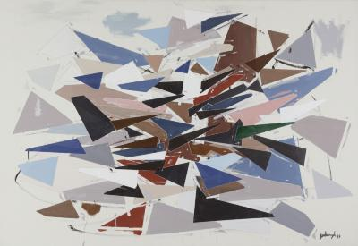 | Untitled  Object identifier: 2016/2.87  Artist/Maker: Robert Goodnough (artist)  Nationality: American (North American)  Object titles: Untitled  Date created: 1967  Medium and Support: oil on canvas  Type: Object  Credit line: Bequest of Gertrude Kasle, Approved: Yes (current) 07/27/2016

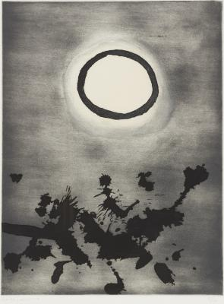 | Untitled  Object identifier: 2016/2.88  Artist/Maker: Adolph Gottlieb (artist)  Nationality: American (North American)  Object titles: Untitled  Date created: 1972  Medium and Support: lithograph on paper  Type: Object  Credit line: Bequest of Gertrude Kasle, Approved: Yes (current) 07/27/2016

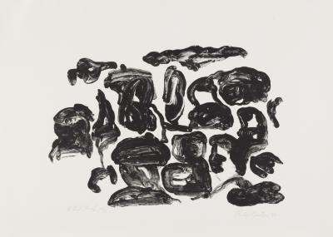 | Untitled VIII/X  Object identifier: 2016/2.89  Artist/Maker: Philip Guston (artist)  Object titles: Untitled VIII/X  Date created: 1966  Medium and Support: ink on paper  Type: Object  Credit line: Bequest of Gertrude Kasle, Approved: Yes (current) 07/27/2016

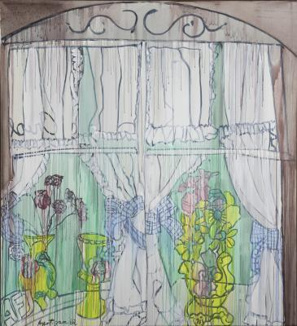 | Fells Point Florist  Object identifier: 2016/2.90  Artist/Maker: Grace Hartigan (artist)  Object titles: Fells Point Florist  Date created: 1982  Medium and Support: oil on canvas  Type: Object  Credit line: Bequest of Gertrude Kasle, Approved: Yes (current) 07/27/2016

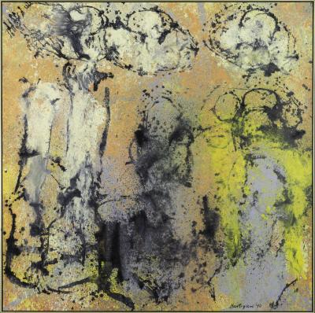 | Notions  Object identifier: 2016/2.91  Artist/Maker: Grace Hartigan (artist)  Object titles: Notions  Date created: 1990  Medium and Support: oil on canvas  Type: Object  Credit line: Bequest of Gertrude Kasle, Approved: Yes (current) 07/27/2016

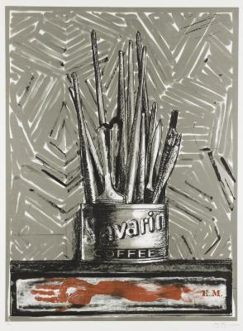 | Savarin  Object identifier: 2016/2.92  Artist/Maker: Jasper Johns (artist)  Nationality: American (North American)  Object titles: Savarin  Date created: 1977 – 1981  Medium and Support: color lithograph on paper  Type: Object  Credit line: Bequest of Gertrude Kasle, Approved: Yes (current) 07/27/2016

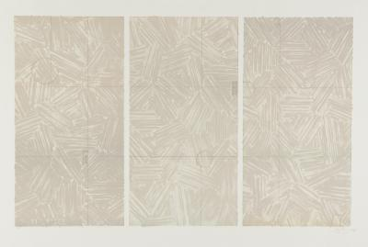 | Usuyuki  Object identifier: 2016/2.93  Artist/Maker: Jasper Johns (artist)  Nationality: American (North American)  Object titles: Usuyuki  Date created: 1979  Medium and Support: color lithograph on paper  Type: Object  Credit line: Bequest of Gertrude Kasle, Approved: Yes (current) 07/27/2016

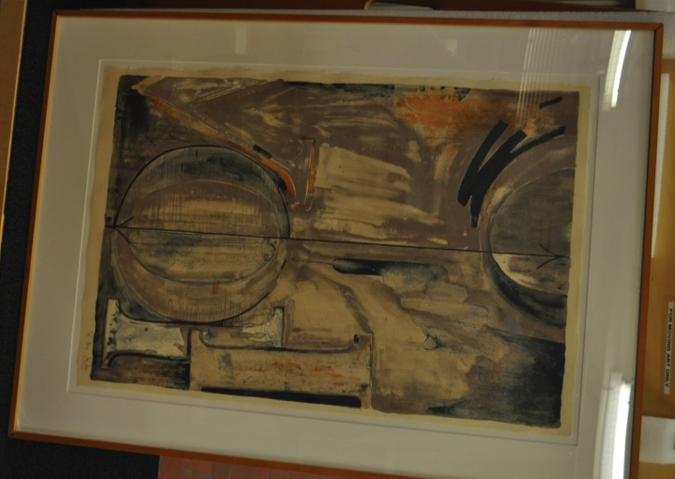 | Voice II (One of a set of three)  Object identifier: 2016/2.95  Artist/Maker: Jasper Johns (artist)  Nationality: American (North American)  Object titles: Voice II (One of a set of three)  Date created: 1982  Medium and Support: color lithograph on paper  Type: Object  Credit line: Bequest of Gertrude Kasle, Approved: Yes (current) 07/27/2016

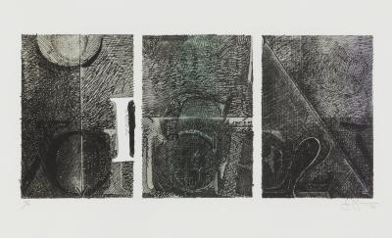 | Voice 2  Object identifier: 2016/2.98  Artist/Maker: Jasper Johns (artist)  Nationality: American (North American)  Object titles: Voice 2  Date created: 1983  Medium and Support: color lithograph on paper  Type: Object  Credit line: Bequest of Gertrude Kasle, Approved: Yes (current) 07/27/2016

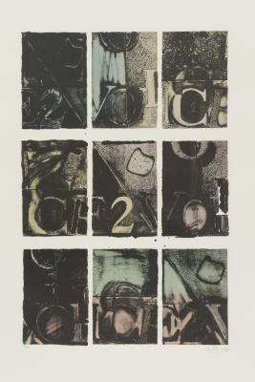 | Voice 2  Object identifier: 2016/2.99  Artist/Maker: Jasper Johns (artist)  Nationality: American (North American)  Object titles: Voice 2  Date created: 1983  Medium and Support: color lithograph on paper  Type: Object  Credit line: Bequest of Gertrude Kasle, Approved: Yes (current) 07/27/2016

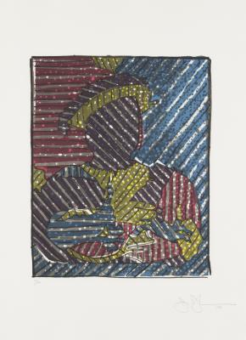 | After Holbein  Object identifier: 2016/2.100  Artist/Maker: Jasper Johns (artist)  Nationality: American (North American)  Object titles: After Holbein  Date created: 1993  Medium and Support: color lithograph on paper  Type: Object  Credit line: Bequest of Gertrude Kasle, Approved: Yes (current) 07/27/2016

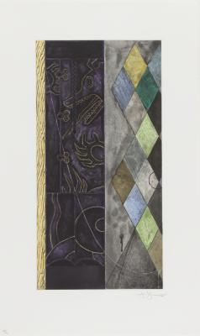 | Untitled  Object identifier: 2016/2.101  Artist/Maker: Jasper Johns (artist)  Nationality: American (North American)  Object titles: Untitled  Date created: 1999  Medium and Support: intaglio on paper  Type: Object  Credit line: Bequest of Gertrude Kasle, Approved: Yes (current) 07/27/2016

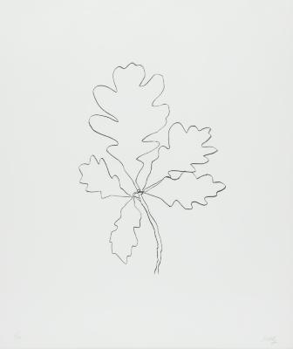 | Oak IV  Object identifier: 2016/2.102  Artist/Maker: Ellsworth Kelly (artist)  Nationality: American (North American)  Object titles: Oak IV  Date created: 1992  Medium and Support: lithograph on paper  Type: Object  Credit line: Bequest of Gertrude Kasle, Approved: Yes (current) 07/27/2016

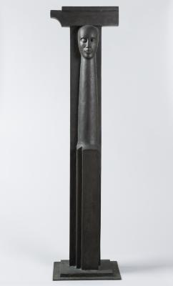 | Caryatid VII  Object identifier: 2016/2.103  Artist/Maker: Susanna Linburg (artist)  Object titles: Caryatid VII  Date created: 1981 – 1987  Medium and Support: bronze  Type: Object  Credit line: Bequest of Gertrude Kasle, Approved: Yes (current) 07/27/2016

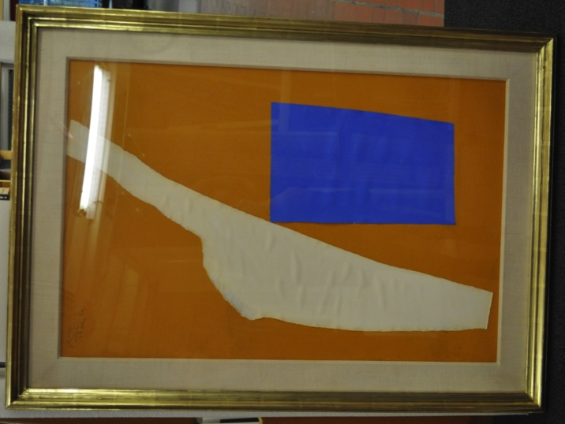 | Summertime with Blue  Object identifier: 2016/2.104  Artist/Maker: Robert Motherwell (artist)  Nationality: American (North American)  Object titles: Summertime with Blue  Date created: 07/28/1974  Medium and Support: acrylic and paper on board  Type: Object  Credit line: Bequest of Gertrude Kasle, Approved: Yes (current) 07/27/2016

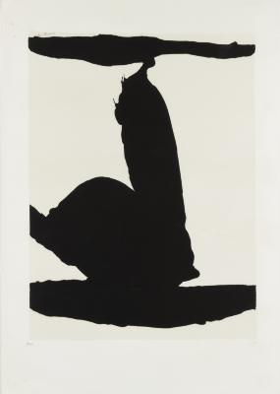 | Africa 1  Object identifier: 2016/2.105  Artist/Maker: Robert Motherwell (artist)  Nationality: American (North American)  Object titles: Africa 1  Date created: 1970  Medium and Support: silkscreen on paper  Type: Object  Credit line: Bequest of Gertrude Kasle, Approved: Yes (current) 07/27/2016

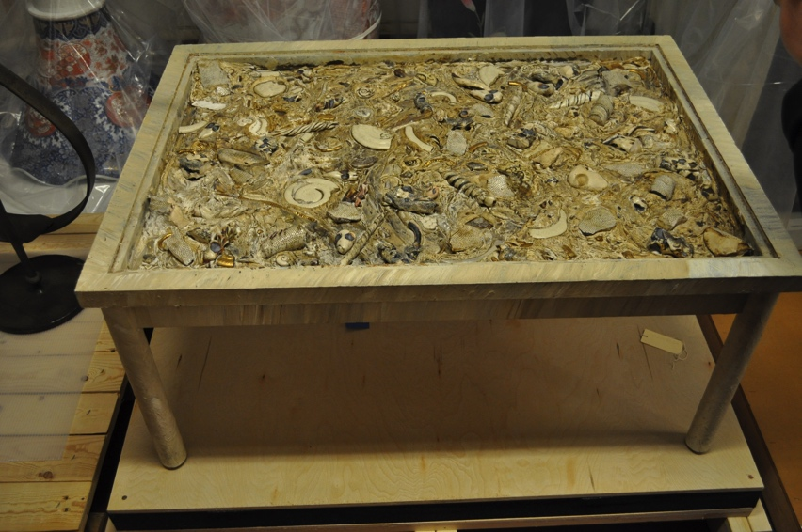 | Autobiographical Table II  Object identifier: 2016/2.106  Artist/Maker: Michele Oka Doner (artist)  Nationality: American (North American)  Object titles: Autobiographical Table II  Date created: 1984 – 1994  Medium and Support: ceramic, mixed media and painted wood  Type: Object  Credit line: Bequest of Gertrude Kasle, Approved: Yes (current) 07/27/2016

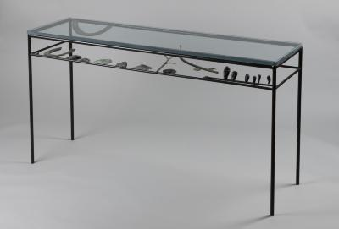 | Amulets  Object identifier: 2016/2.107  Artist/Maker: Michele Oka Doner (artist)  Nationality: American (North American)  Object titles: Amulets  Date created: 1985 – 1995  Medium and Support: bronze and glass  Type: Object  Credit line: Bequest of Gertrude Kasle, Approved: Yes (current) 07/27/2016

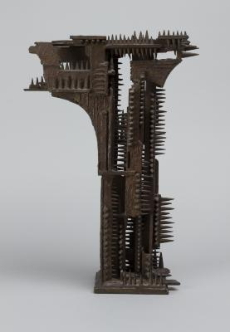 | Study for Gates of the Six Million  Object identifier: 2016/2.113  Artist/Maker: William Tarr (artist)  Nationality: American (North American)  Object titles: Study for Gates of the Six Million  Date created: 1975 – 1985  Medium and Support: bronze  Type: Object  Credit line: Bequest of Gertrude Kasle, Approved: Yes (current) 07/27/2016

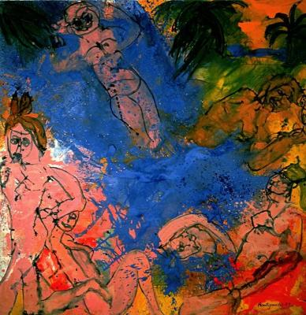 | Tarzana  Object identifier: 1992/1.129  Artist/Maker: Grace Hartigan (artist)  Object titles: Tarzana  Date created: 1987  Medium and Support: oil on canvas  Type: Object  Credit line: Gift of Gertrude and Leonard Kasle, Approved: No (current) 01/26/2016

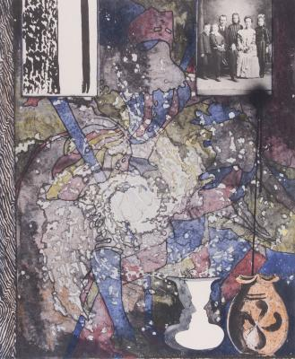 | Untitled  Object identifier: 2008/2.218  Artist/Maker: Jasper Johns (artist)  Nationality: American (North American)  Object titles: Untitled  Date created: 1994  Medium and Support: mixed media on woodcut  Type: Object  Credit line: Gift of Gertrude and Leonard Kasle, Approved: No (current) 01/26/2016

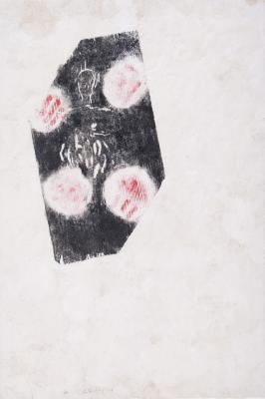 | Untitled  Object identifier: 2008/2.217  Artist/Maker: Susan Rothenberg (artist)  Object titles: Untitled  Date created: 1984  Medium and Support: mixed media on lithograph  Type: Object  Credit line: Gift of Gertrude and Leonard Kasle, Approved: No (current) 01/26/2016

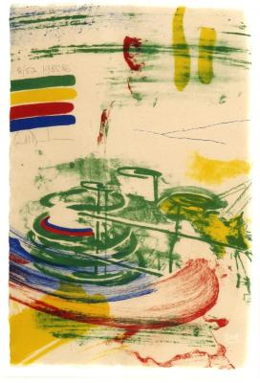 | Color Messages A  Object identifier: 2011/1.59  Artist/Maker: Carroll Dunham (artist)  Object titles: Color Messages A  Date created: 1986  Medium and Support: lithograph on paper  Type: Object  Credit line: Gift of Gertrude Kasle, Approved: No (current) 01/26/2016

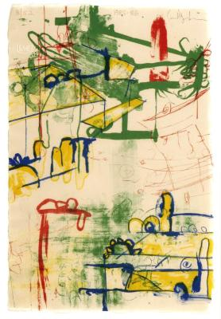 | Color Messages B  Object identifier: 2011/1.68  Artist/Maker: Carroll Dunham (artist)  Object titles: Color Messages B  Date created: 1986  Medium and Support: lithograph on paper  Type: Object  Credit line: Gift of Gertrude Kasle, Approved: No (current) 01/26/2016

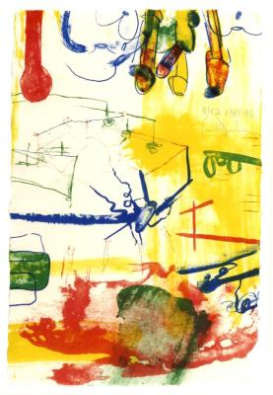 | Color Messages C  Object identifier: 2011/1.62  Artist/Maker: Carroll Dunham (artist)  Object titles: Color Messages C  Date created: 1986  Medium and Support: lithograph on paper  Type: Object  Credit line: Gift of Gertrude Kasle, Approved: No (current) 01/26/2016

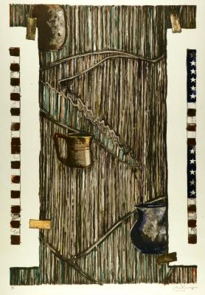 | Ventriloquist  Object identifier: 2011/1.61  Artist/Maker: Jasper Johns (artist)  Nationality: American (North American)  Object titles: Ventriloquist  Date created: 1985  Medium and Support: lithograph on paper  Type: Object  Credit line: Gift of Gertrude Kasle, Approved: No (current) 01/26/2016

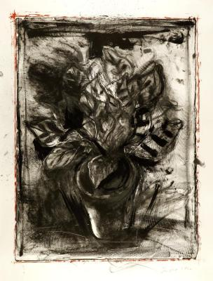 | Jerusalem Plant  Object identifier: 2011/1.70  Artist/Maker: Jim Dine (artist)  Object titles: Jerusalem Plant  Date created: 1982  Medium and Support: lithograph on paper  Type: Object  Credit line: Gift of Gertrude Kasle, Approved: No (current) 01/26/2016

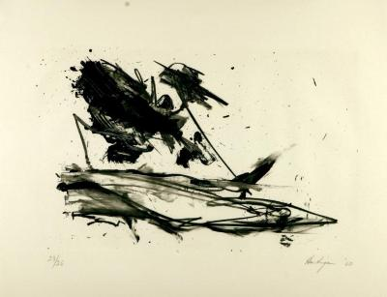 | The Hero Leaves His Ship III  Object identifier: 2011/1.63  Artist/Maker: Grace Hartigan (artist)  Object titles: The Hero Leaves His Ship III  Date created: 1960  Medium and Support: lithograph on paper  Type: Object  Credit line: Gift of Gertrude Kasle, Approved: No (current) 01/26/2016

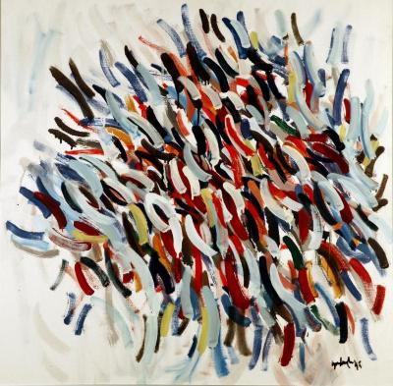 | Untitled  Object identifier: 2011/1.60  Artist/Maker: Robert Goodnough (artist)  Nationality: American (North American)  Object titles: Untitled  Date created: 1975  Medium and Support: oil on canvas  Type: Object  Credit line: Gift of Gertrude Kasle, Approved: No (current) 01/26/2016

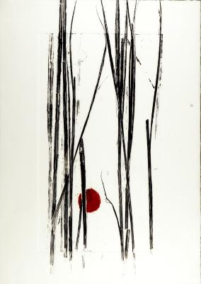 | Untitled  Object identifier: 2011/1.64  Artist/Maker: Pamela Sumner (artist)  Object titles: Untitled  Date created: 1995 – 2005  Medium and Support: Chinese ink on paper  Type: Object  Credit line: Gift of Gertrude Kasle, Approved: No (current) 01/26/2016

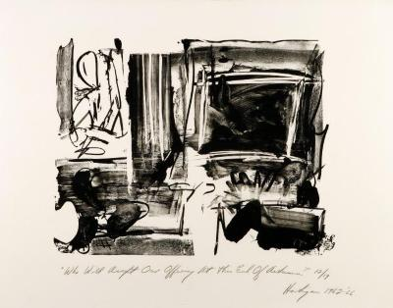 | Who Will Accept Our Offering At This End Of Autumn?  Object identifier: 2011/1.67  Artist/Maker: Grace Hartigan (artist)  Object titles: Who Will Accept Our Offering At This End Of Autumn?  Date created: 1962 – 1966  Medium and Support: lithograph on paper  Type: Object  Credit line: Gift of Gertrude Kasle, Approved: No (current) 01/26/2016

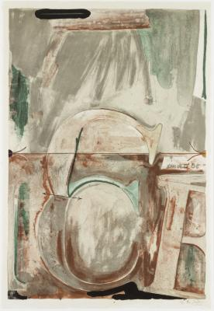 | Voice II (Two of a set of three)  Object identifier: 2016/2.96  Artist/Maker: Jasper Johns (artist)  Nationality: American (North American)  Object titles: Voice II (Two of a set of three)  Date created: 1982  Medium and Support: color lithograph on paper  Type: Object  Credit line: Bequest of Gertrude Kasle, Approved: Yes (current) 07/27/2016

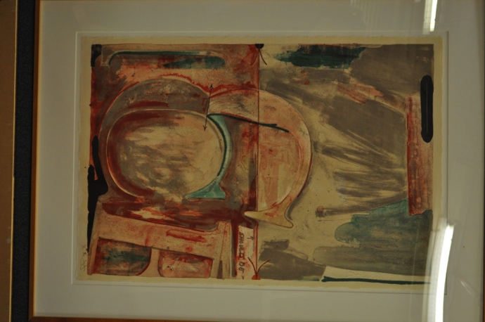 | Voice II (Three of a set of three)  Object identifier: 2016/2.97  Artist/Maker: Jasper Johns (artist)  Nationality: American (North American)  Object titles: Voice II (Three of a set of three)  Date created: 1982  Medium and Support: color lithograph on paper  Type: Object  Credit line: Bequest of Gertrude Kasle, Approved: Yes (current) 07/27/2016

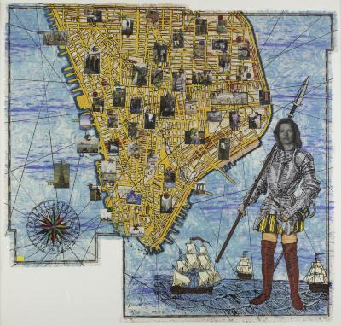 | The Wonderfulness of Downtown  Object identifier: 2016/2.114  Artist/Maker: Jane Hammond (artist)  Nationality: American (North American)  Object titles: The Wonderfulness of Downtown  Date created: 1996  Medium and Support: screenprint and lithograph with collage elements on paper  Type: Object  Credit line: Bequest of Gertrude Kasle, Approved: Yes (current) 07/27/2016

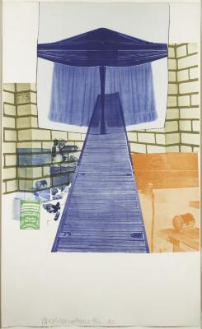 | Lithograph IV  Object identifier: 2016/2.108  Artist/Maker: Robert Rauschenberg (artist)  Nationality: American (North American)  Object titles: Lithograph IV  Date created: 1980  Medium and Support: lithograph on paper  Type: Object  Credit line: Bequest of Gertrude Kasle, Approved: Yes (current) 07/27/2016

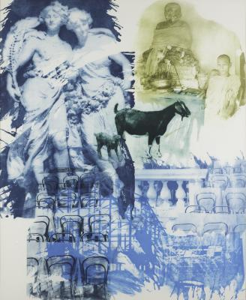 | Intermission  Object identifier: 2016/2.109  Artist/Maker: Robert Rauschenberg (artist)  Nationality: American (North American)  Object titles: Intermission  Date created: 1996  Medium and Support: intaglio on paper  Type: Object  Credit line: Bequest of Gertrude Kasle, Approved: Yes (current) 07/27/2016

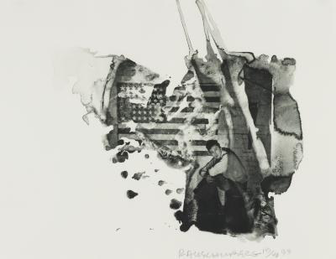 | Jap  Object identifier: 2016/2.110  Artist/Maker: Robert Rauschenberg (artist)  Nationality: American (North American)  Object titles: Jap  Date created: 1999  Medium and Support: intaglio on paper  Type: Object  Credit line: Bequest of Gertrude Kasle, Approved: Yes (current) 07/27/2016

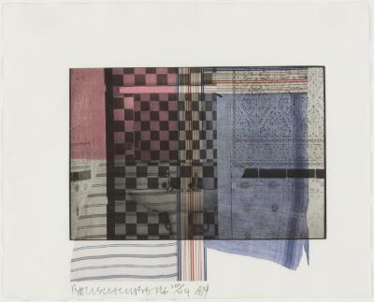 | Faus  Object identifier: 2016/2.111  Artist/Maker: Robert Rauschenberg (artist)  Nationality: American (North American)  Object titles: Faus  Date created: 1984  Medium and Support: lithograph on paper  Type: Object  Credit line: Bequest of Gertrude Kasle, Approved: Yes (current) 07/27/2016

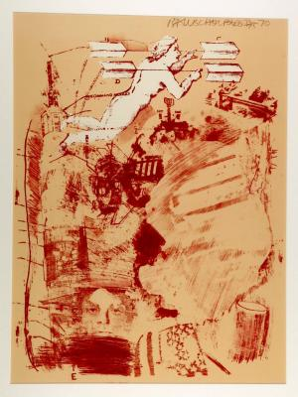 | Score  Object identifier: 2011/1.66  Artist/Maker: Robert Rauschenberg (artist); Gemini G.E.L. (printer)  Nationality: American (North American);American (North American)  Object titles: Score  Date created: 1970  Medium and Support: lithograph on paper  Type: Object  Credit line: Gift of Gertrude Kasle, Approved: No (current) 01/26/2016

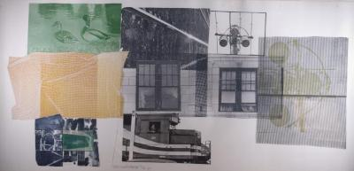 | 5:29 Bay Shore  Object identifier: 2011/1.69  Artist/Maker: Robert Rauschenberg (artist)  Nationality: American (North American)  Object titles: 5:29 Bay Shore  Date created: 1981  Medium and Support: lithograph in 10 colors with collage on Arches 88 and Kitakata Japanese chine collé paper  Type: Object  Credit line: Gift of Gertrude Kasle, Approved: No (current) 01/26/2016

