1. 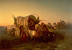 Attack on an Emigrant Train - Charles Ferdinand Wimar (1856)
World Literature and Art - UMMA Tour - Pioneer High School

2. 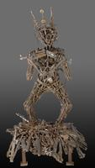 Apsara Warrior - Ouk Chim Vichet (2003)

3. Aftermath Exhibit 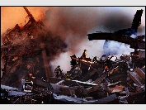 New York 9-11-01 - 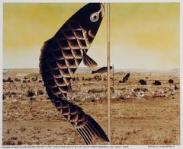 Japanese Children’s Day Carp Banners –
Peter Turnley (2001) Patrick Nagatani (1990)

4. Red Circle Posters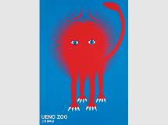 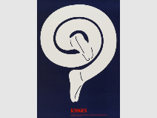 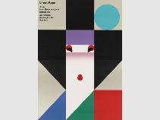 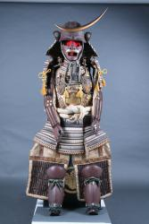 Samurai 19thcentury

5. 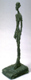 Standing Figure - Alberto Giacometti (1957) 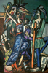 Begin the Beguine - Max Beckmann (1946)

My reflections on general themes (stories) in the art we saw today - destruction, survival, rebuilding, personal / cultural identity-
how they influence my understanding of the books we’ve been reading, and vice versa. I used to think…… and now I think…..

