Alberto Giacometti
Standing Figure (1958/1.137)

March 28, 2009
Giacometti often proclaimed his interest in exploring in sculpture his ideas about vision and perception, and particularly in rendering in three dimensions the phenomenon of vanishing point perspective so easily captured in painting. Notwithstanding his own description of his formal concerns, by the late 1940s, Giacometti was widely regarded as the artist who best represented Existential angst in the aftermath of the two World Wars. Some scholarship suggests that the skeletal thinness of his figures during this period was a manifestation of working through trauma from the ever-increasing flow of evidence from the Nazi concentration camps; the artist is also said to have begun to sculpt in this style soon after he visited the exhibition “Art and Resistance” (1946), where he would have seen grisly images of emaciated prisoners and piles of naked corpses, some drawn and painted by his friend and neighbor Boris Taslitsky, who had been interned at Buchenwald. While we cannot know if Giacometti is directly referencing these powerful images, his work was produced in a historical moment deeply affected by them, and they heavily influenced the prevailing interpretation of his sculpture.

After World War II, Giacometti turned from his earlier Cubist and Surrealist work and became especially interested in creating figures that would always appear to the viewer as if from a great distance, no matter how close one stood. He achieved this by paring the figure down to its essential components and by making the figure as lean as possible. But Giacometti's fragile men and women are also inseparable from the post-war attitudes that were crystallized in the writings of French philosopher Jean-Paul Sartre. An ardent admirer of Giacometti, Sartre believed that it was naive to hope for any higher purpose in life since man, though free, was alone and responsible only to himself for his actions. Giacometti's emaciated, post-Holocaust figures with their eroded, crumbling surfaces suggest the antithesis of heroism or nobility, associations traditionally linked to European sculpture.
An avid people-watcher, Giacometti drew his inspiration from the world around him:
"In the streets people astound and interest me more than any sculpture or painting. Every second the people stream together and go apart, then they approach each other to get closer to one another. They unceasingly form and re-form living compositions in unbelievable complexity...It's the totality of life that I want to reproduce in everything do."
Sean M. Ulmer, University Curator of Modern and Contemporary Art, for "A Matter of Degree: Abstraction in Twentieth-Century Art," November 10, 2001 - January 27, 2002

While studying sculpture in Paris in the 1920s, Alberto Giacometti became intrigued with the carved wooden African and South Pacific artifacts on display at the ethnography museums and botanical gardens in that city. He saw a new level of realism in the pieces, believing that their distorted features expressed spiritual truths more effectively than naturalistic representations ever could. After the inhuman devastation of the Second World War, Giacometti also became interested in the philosophy and literature of existentialism, and sought a way to depict the spiritual alienation of human beings. Out of the artist’s struggle to communicate this existential desolation and metaphysical despair came the thin, broad-shouldered and spindly-limbed faceless figures Giacometti sculpted from 1952 to 1958. "Standing Figure" was done a year after he first exhibited a series of these figures in the French section of the Venice Biennale, a major international exhibition.
(A. Dixon, 20th Century Gallery installation, June 1999)

Boris Tislitzky site: http://boris-taslitzky.fr/accueil.htm
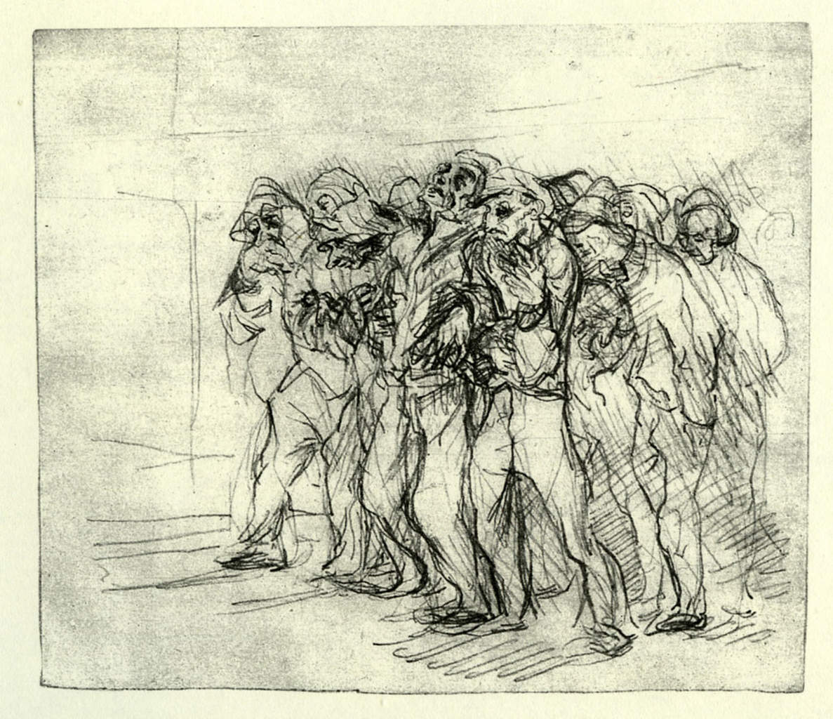
images: http://lesvoivres88240.over-blog.com/2015/01/il-y-70-ans-la-liberation-d-auschwitz-birkenau.html

